**Batch Information:**

* **Batch Start Date:** 2025-08-04
* **Batch Name:** WiproNGA_DWS_B5_25VID2550
* **First Name:** Tejas
* **Last Name:** Zinjade
* **User ID:** 34957
* **Batch ID:** B5-25VID255
* **POWERSHELL CMDLET COMMAND**

Get-NetIPConfiguration | Out-File 'D:\WIPRO TRAINING\NetIp.txt'

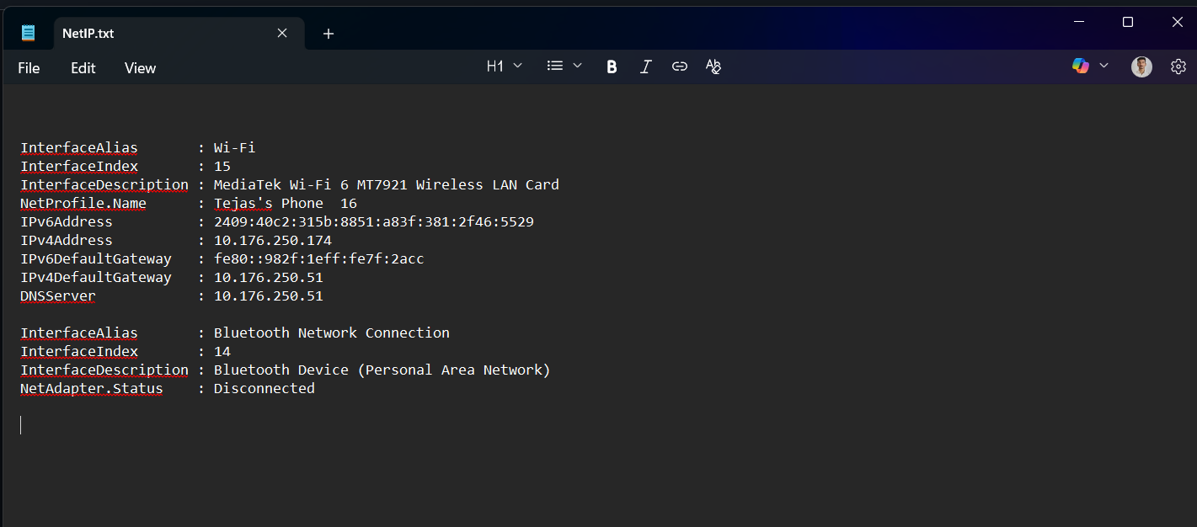

Get-Service | Out-File 'D:\WIPRO TRAINING\NetIp.txt' -Append

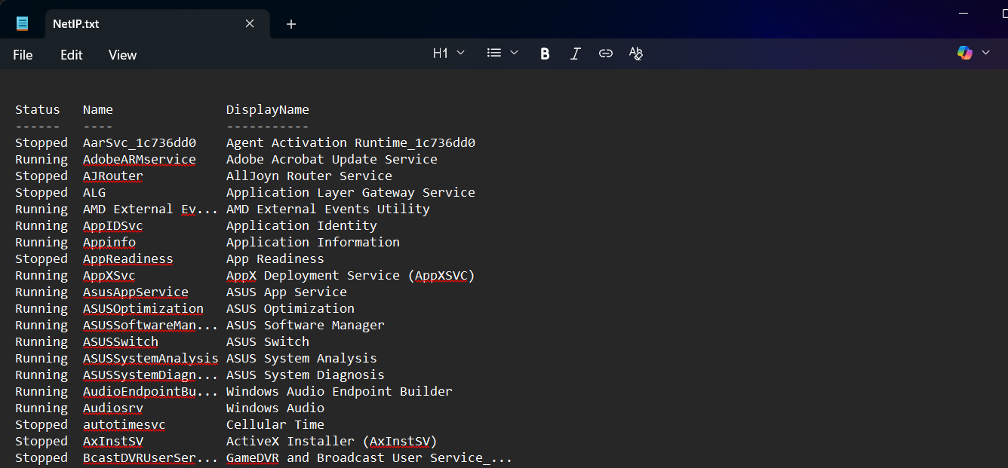

Get-PSDrive -PSProvider FileSystem

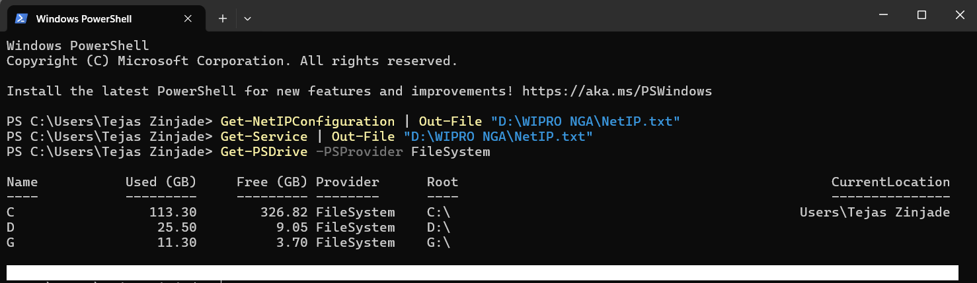

Get-ChildItem

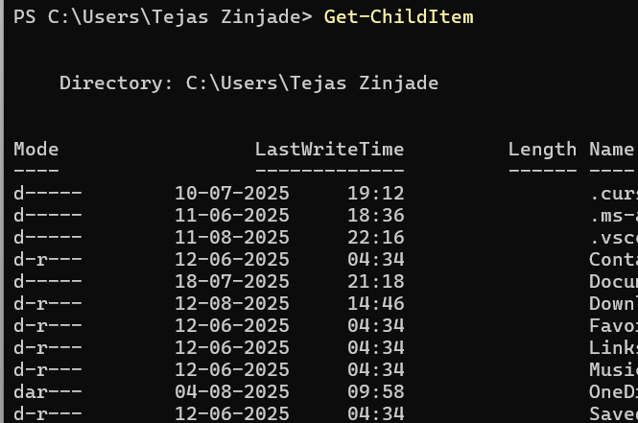

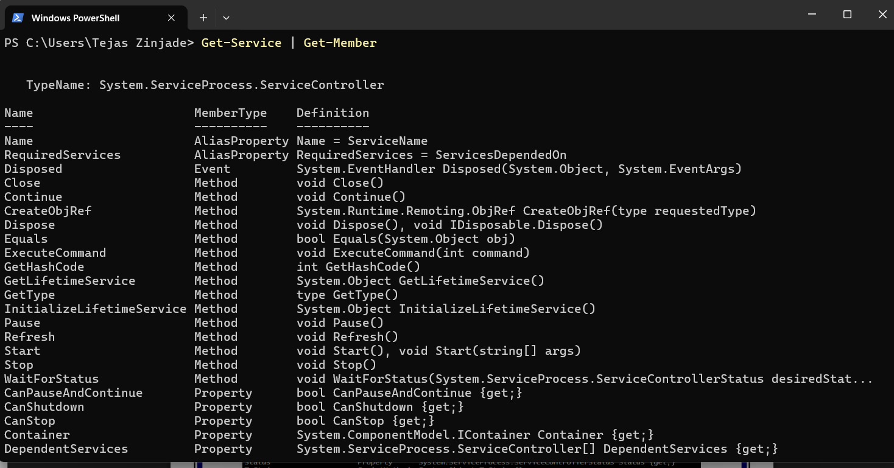

Get-Service | Get-Member

Get-Date | Select-Object -Property Second

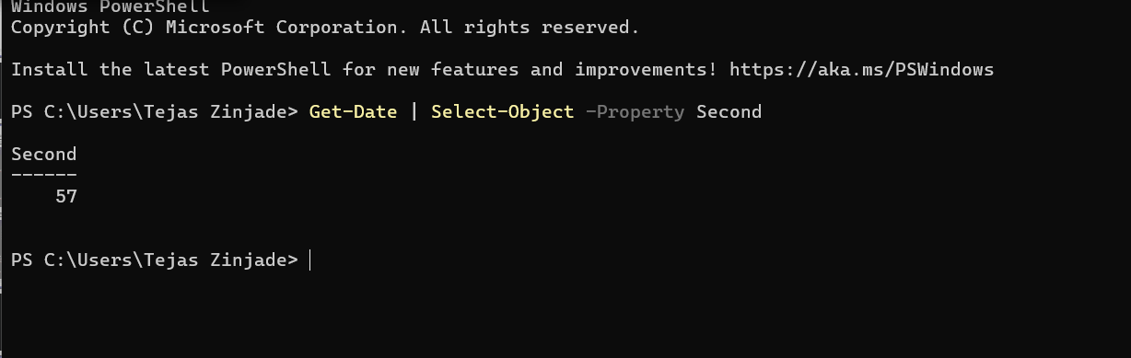

Get-Command *hotfix*

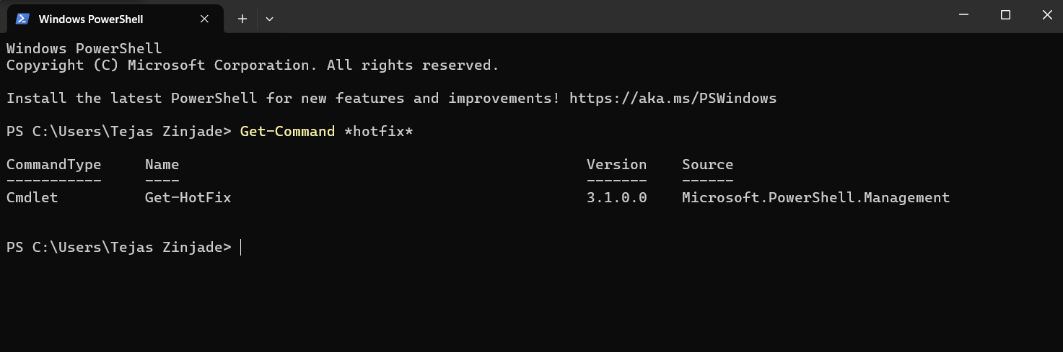

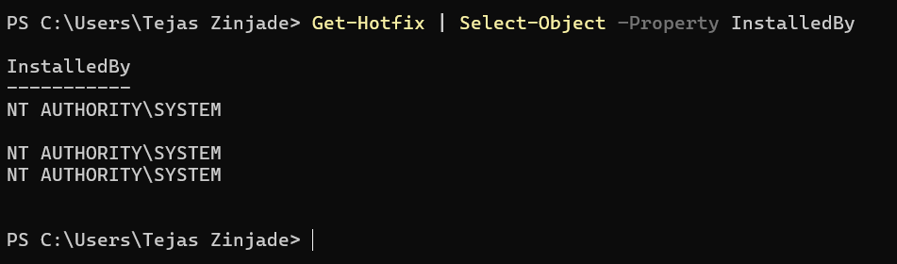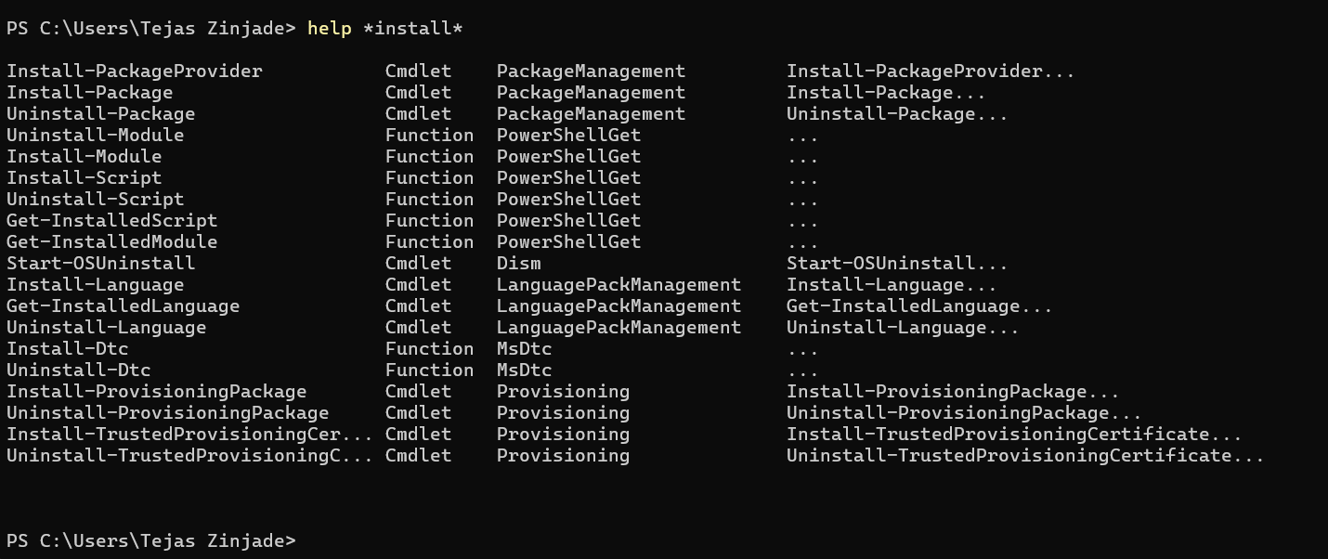

Get-Hotfix | Select-Object –Property InstalledBy

help *install*

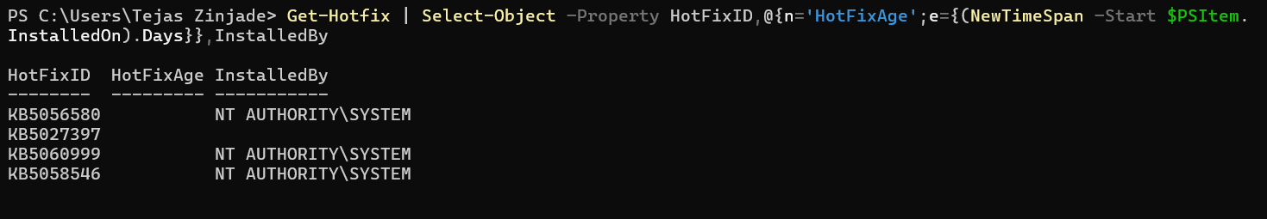

Get-Hotfix | Select-Object –Property HotFixID,@{n='HotFixAge';e={(New- TimeSpan –Start $PSItem.InstalledOn).Days}},InstalledBy

Get-NetFirewallProfile

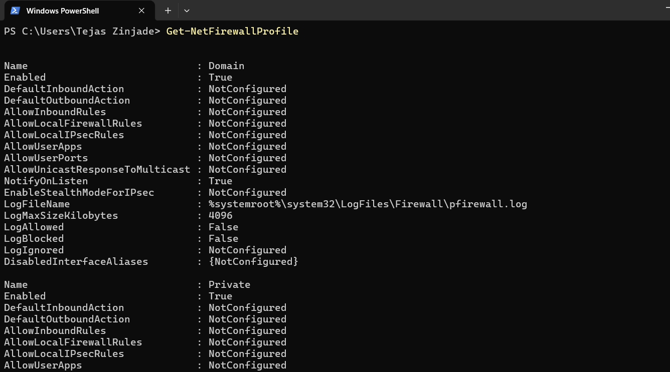

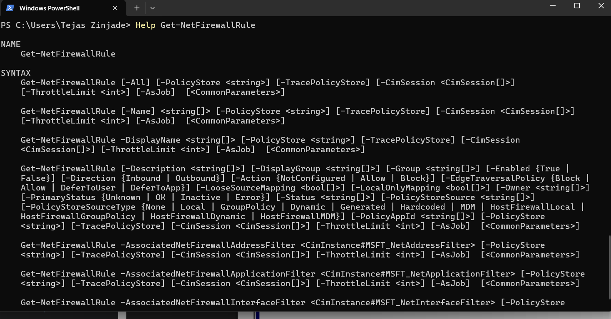

Help Get-NetFirewallRule

Help Get-NetFirewallRule -ShowWindow

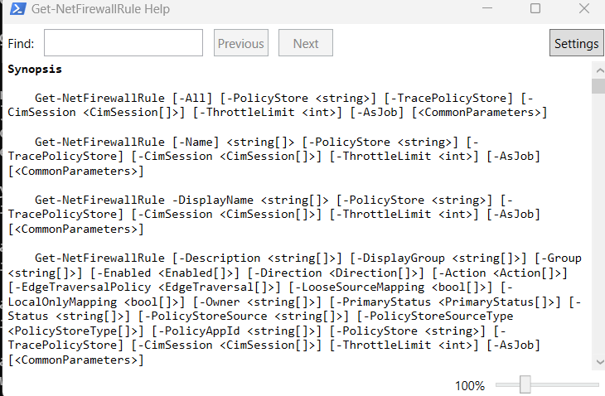

Get-NetFirewallRule –Enabled True | Format-Table -wrap | -First 5

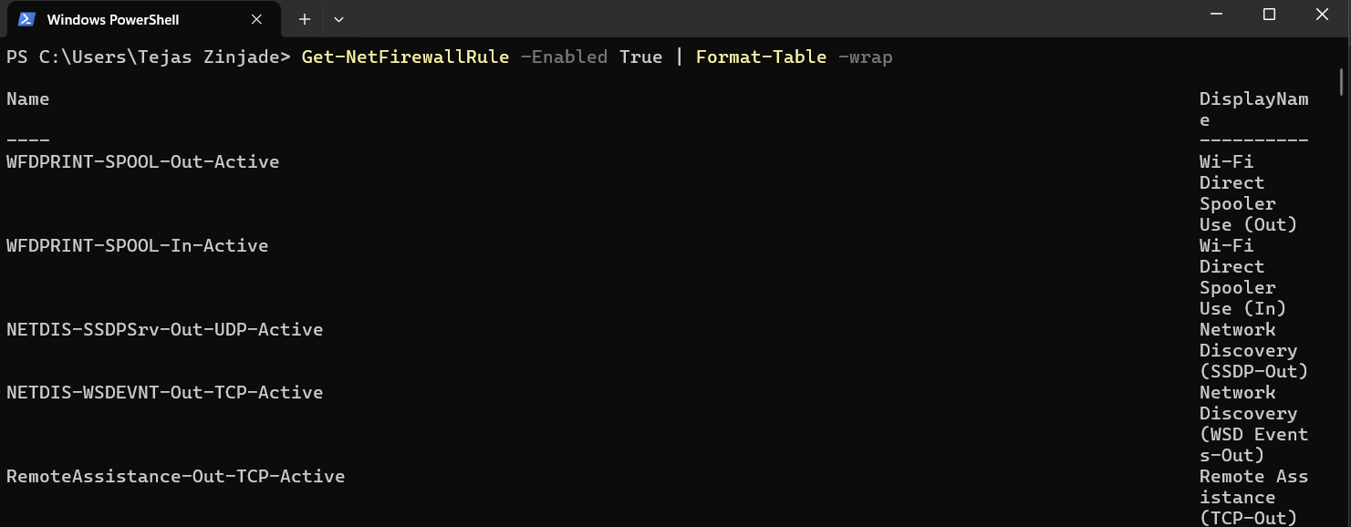

100 -gt 10

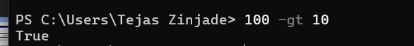



'hello' -eq 'HELLO'

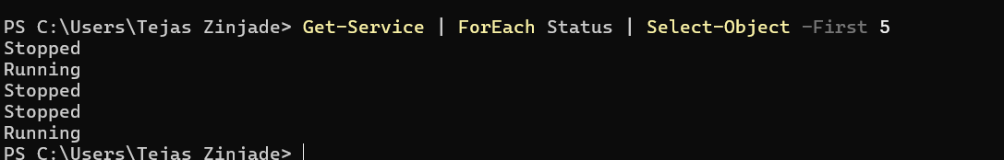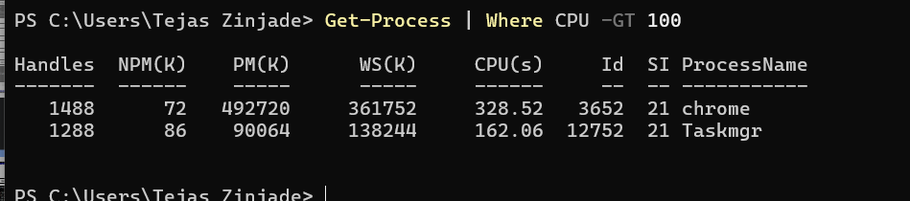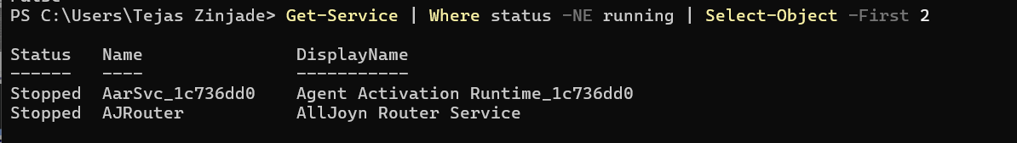****

Get-Service | ForEach Status | Select-Object -First 5

Get-Process | Where CPU -GT 100

Get-Service | Where status -NE running | Select-Object -First 2

'hello' -ceq 'HELLO'

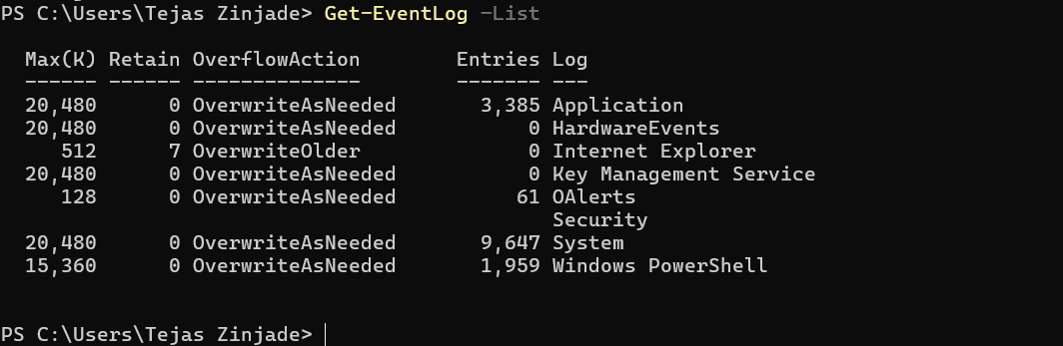

Get-EventLog –List

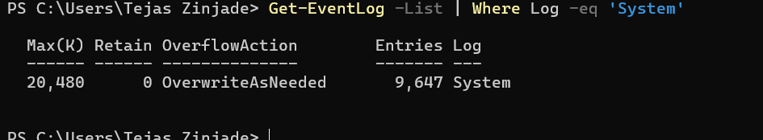

Get-EventLog -List | Where Log -eq 'System'

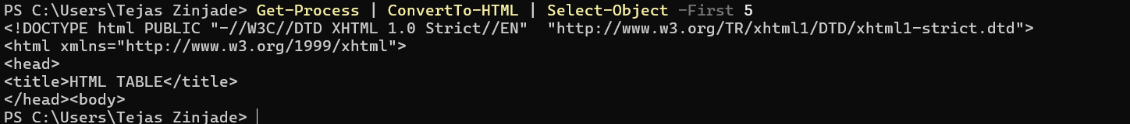

Get-CimClass *network* | Sort CimClassName

Get-Process | ConvertTo-HTML | Select-Object -First 5

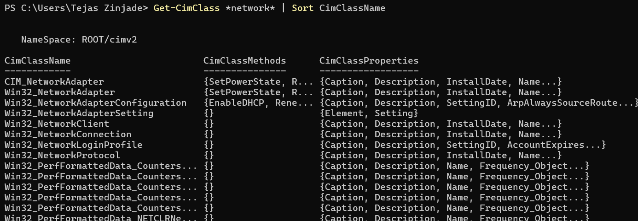

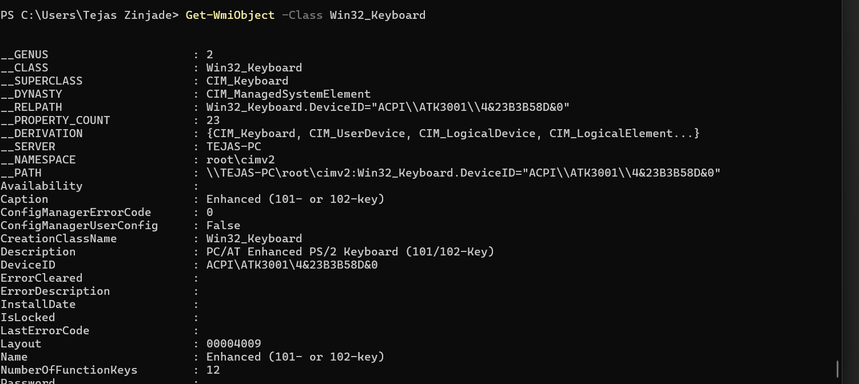

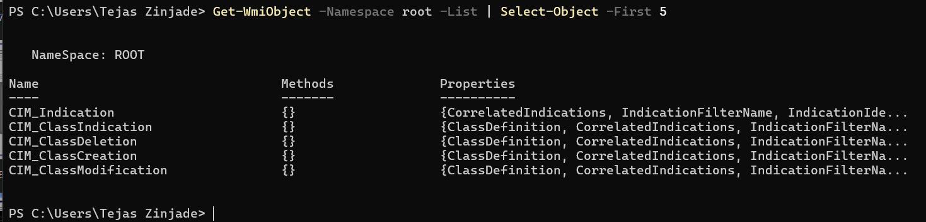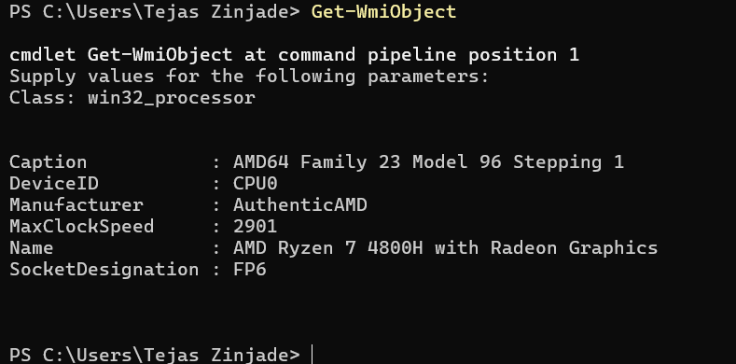

Get-WmiObject -Namespace root -List | Select-Object -First 5

Get-WmiObject

Get-WmiObject -Class Win32_Keyboard

Get-WmiObject -Class CIM_Chip

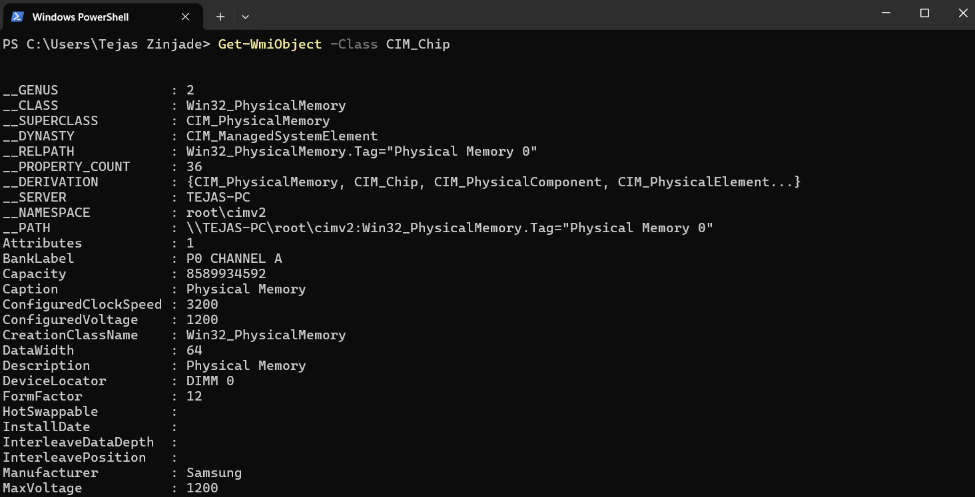

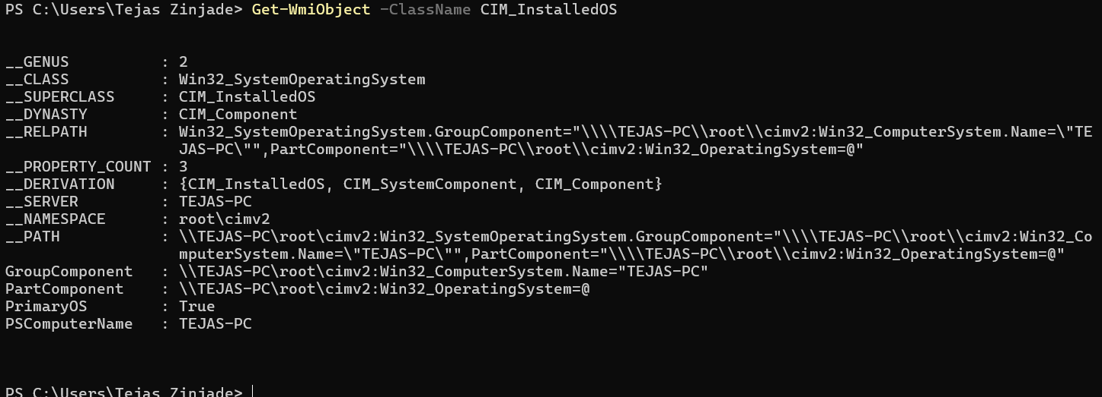

Get-WmiObject -Class Win32_LogicalDisk -Filter "DriveType=3"

Get-WmiObject -ClassName CIM_InstalledOS

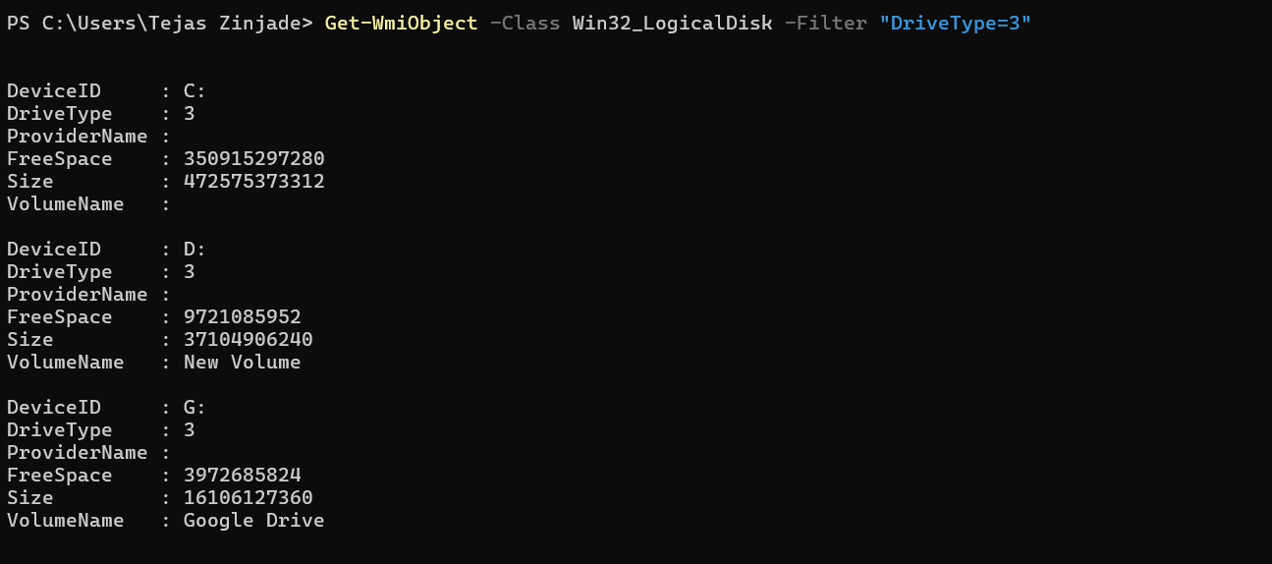

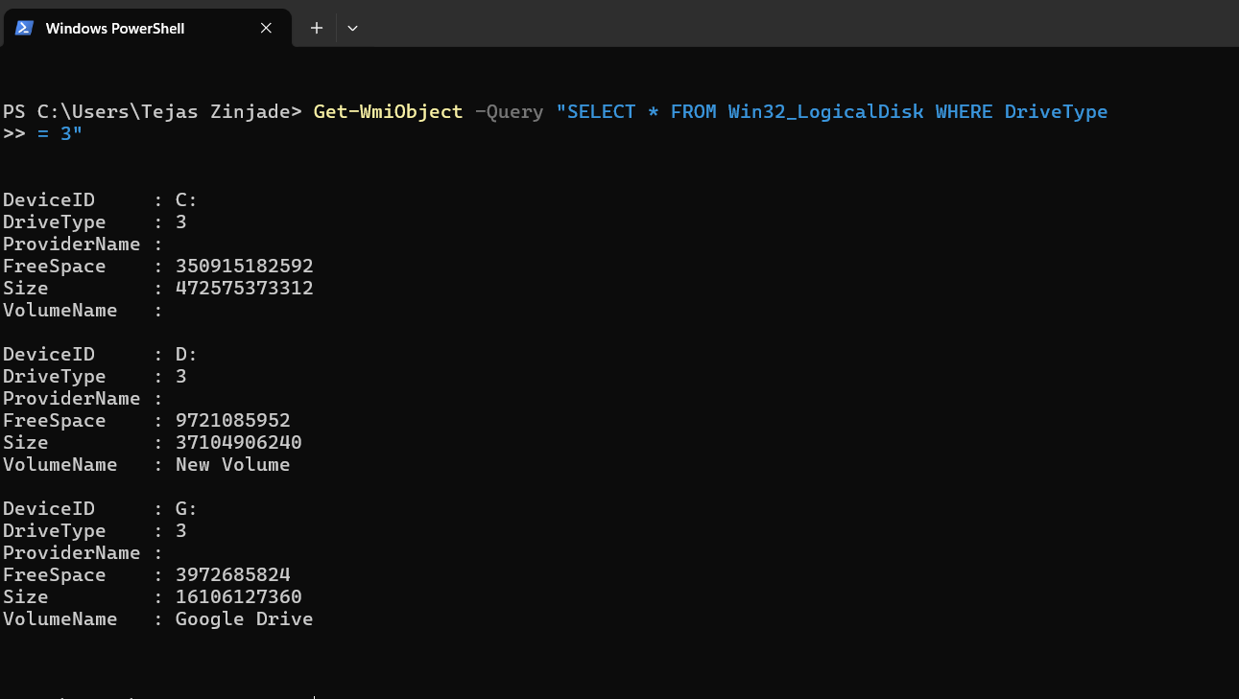

Get-WmiObject -Query "SELECT * FROM Win32_LogicalDisk WHERE DriveType

= 3"